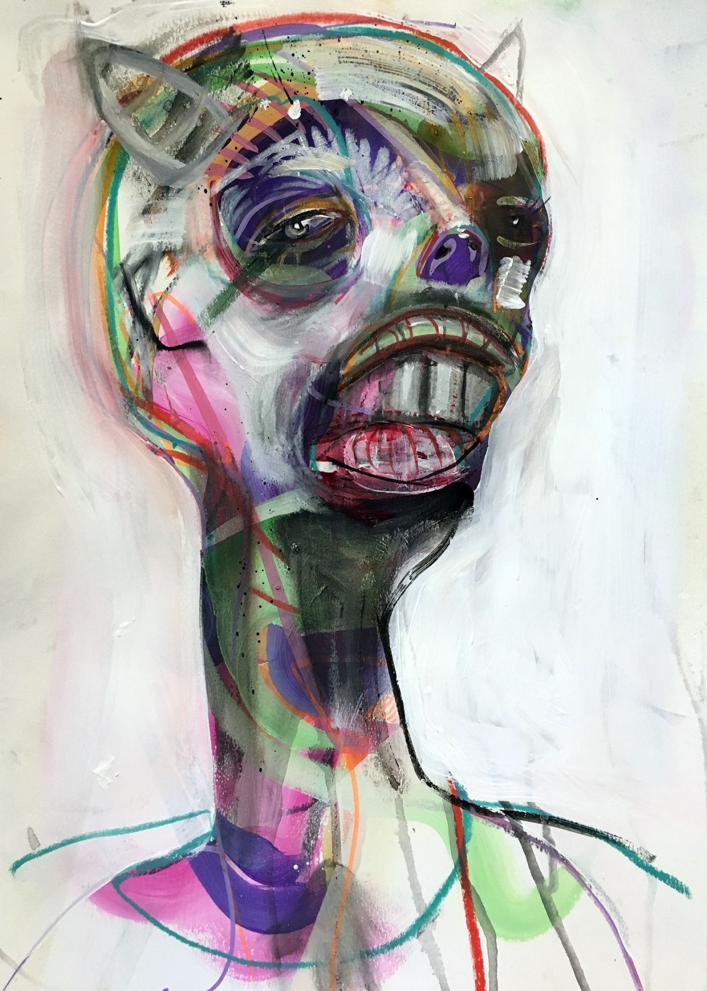
Image :("It's not even" by artist Darren MacPherson)

You've had me close, you've seen me bare, bruised, and brittle.You've seen it everyday,you've faced it all the time.For you it was a shock at first, and now,you're habituated, habituated to my misfit thoughts,habituated to my regular struggles,habituated of seeing me fight it back.

You're fed up, you want to see me win over it,but I fail,and it frustrates you.

It does the same to me,the only difference is,I never get habituated,it is as intense as it was in the beginning,as confusing and suffocating as it was since inception.
They say being normal is boring.

Sometimes,that boredom too,is a privilege.

Sometimes,being normal is the best thing that could happen to you.

I didn't realize this till I saw your struggles to cope up with me.Till I saw I was destroying more in order to create.

I've been torn between enjoying being myself and trying to hold on to what makes me.

And I hate every part of it.

I hate this trade off of wants and needs.

I hate drifting into the reality that I made up in my mind because it makes me abominable and misunderstood,and I hate to hate it because it made me.
I wish it was easy,I wish there was a switch to turn it on or off.

I wish I hadn't let you be close to me, only to make you suffer.
I wish, I could be normal.

